## [報表] 使用UI查詢結果匯出pdf報表並自訂格式

Shared by: Gilbert Lin

**Problem:**

使用UI查詢結果匯出pdf報表並自訂格式

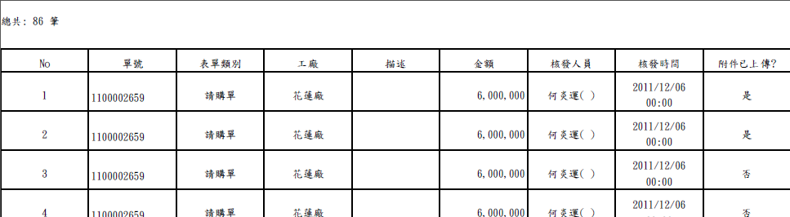

**Solution:**

**配合Velocity framework 及fileDownload匯出pdf**

1. **authfileQuery.xhtml**

…

<p:commandLink rendered="#{authfileQuery.queryResults ne null}"

actionListener="#{authfileQuery.export}"

ajax="false" onclick="setUpBlockUI();"

>

<h:graphicImage width="30" height="35" alt="export to pdf" library="images" name="pdf-icon.png" style="vertical-align: bottom; border-style: none" />

<h:panelGroup>

<h:outputLabel value="#{msg['sluggish.export.pdf']}"/>

</h:panelGroup>

<p:fileDownload rendered="#{!empty authfileQuery.file}" value="#{authfileQuery.file}" />

</p:commandLink>

…

1. **AuthFileQueryController.java**

public void export() {

try {

final ByteArrayOutputStream out = new ByteArrayOutputStream();

PDFExporter pdfExporter = new PDFExporter();

pdfExporter.parseVelocityTemplate(this.queryResults, "auth_file_table_include.vm", out);

InputStream in = new ByteArrayInputStream(out.toByteArray());

this.setFile(ExportUtil.genFile(in, templateName, extensionName));

} catch (Exception ex) {

logger.error("", ex);

}

}

…

1. **auth_file_table_include.vm**

總共: $bean.authInfos.size() 筆

|  |  |  |  |  |  |  |  |  |
| --- | --- | --- | --- | --- | --- | --- | --- | --- |
| **No** | **單號** | **表單類別** | **工廠** | **描述** | **金額** | **核發人員** | **核發時間** | **附件已上傳?**#set( $index = 1 ) #foreach($item in $bean.authInfos) |
| $index | [$item.fileno]($!item.url) | $item.fileTypeDesc | $!item.factoryName | $!item.description | $!item.totalAmountDesc | $!item.creator | $!item.createtimestampDesc | #if($!item.attachmentList.size()>0) 是 #else 否 #end #set( $index = $index + 1 ) #end |

**Ref:**

**1.** **PDFExporter.java**



**2.Exportutil.java**



1. **auth_file_table_include.vm**